**DAILY ONLINE ACTIVITIES SUMMARY**

|  |  |  |  |  |  |  |  |  |
| --- | --- | --- | --- | --- | --- | --- | --- | --- |
| **Date:** | **1-06-2020** | | | | | **Name:** | **kavya** | |
| **Sem & Sec** | **6th & A** | | | | | **USN:** | **4al17cs041** | |
| **Online Test Summary** | | | | | | | | |
| **Subject** | | **Cryptography Network Security & Cyber Laws** | | | | | | |
| **Max. Marks** | | **60** | | **Score** | | | **48** | |
| **Certification Course Summary** | | | | | | | | |
| **Course** | FREE Course on Data Science, Machine Learning, Data Analysis, Data Visualization using Python and R Programming | | | | | | | |
| **Certificate Provider** | | | **Udemy** | | **Duration** | | | **8 Hours** |
| **Coding Challenges** | | | | | | | | |
| **Problem Statement:** **1.** Given an array of positive integers. Write a C Program to find the leaders in the array.  2. Write a Java Program to left rotate the elements of an array  3. Python Program to remove duplicate elements from a list | | | | | | | | |
| **Status: Yes, completed all the programs** | | | | | | | | |
| **Uploaded the report in Github** | | | | | **yes** | | | |
| **If yes Repository name** | | | | | [**https://github.com/kavya-077/DAILY-STATUS**](https://github.com/kavya-077/DAILY-STATUS) | | | |
| **Uploaded the report in slack** | | | | | **yes** | | | |

Online Test Details: (Attach the snapshot and briefly write the report for the same)

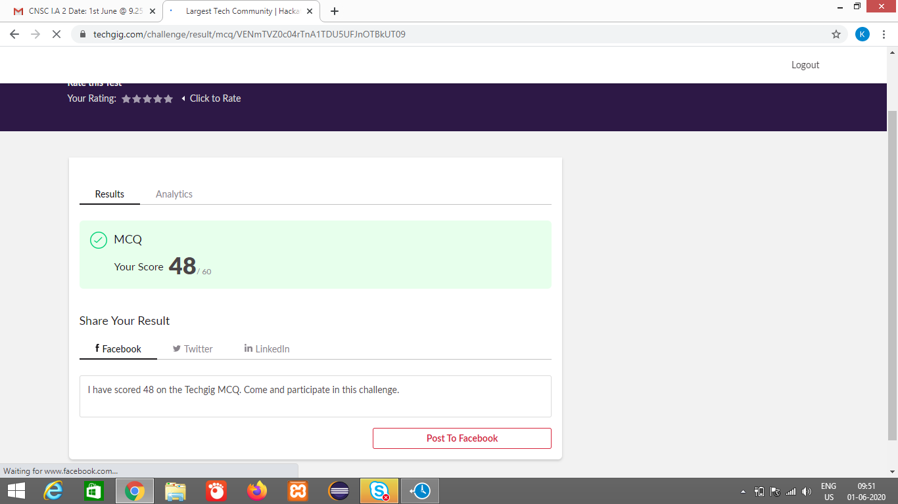

Certification Course Details: (Attach the snapshot and briefly write the report for the same)

**FREE Course on Data Science, Machine Learning, Data Analysis, Data Visualization using Python and R Programming**

**What we’ll learn**

* What is Data Science
* Artificial Intelligence vs Machine Learning vs Deep Learning
* Data Analysis using Python and R
* Data Visualization using Python and R
* Data Loading using Python and R
* 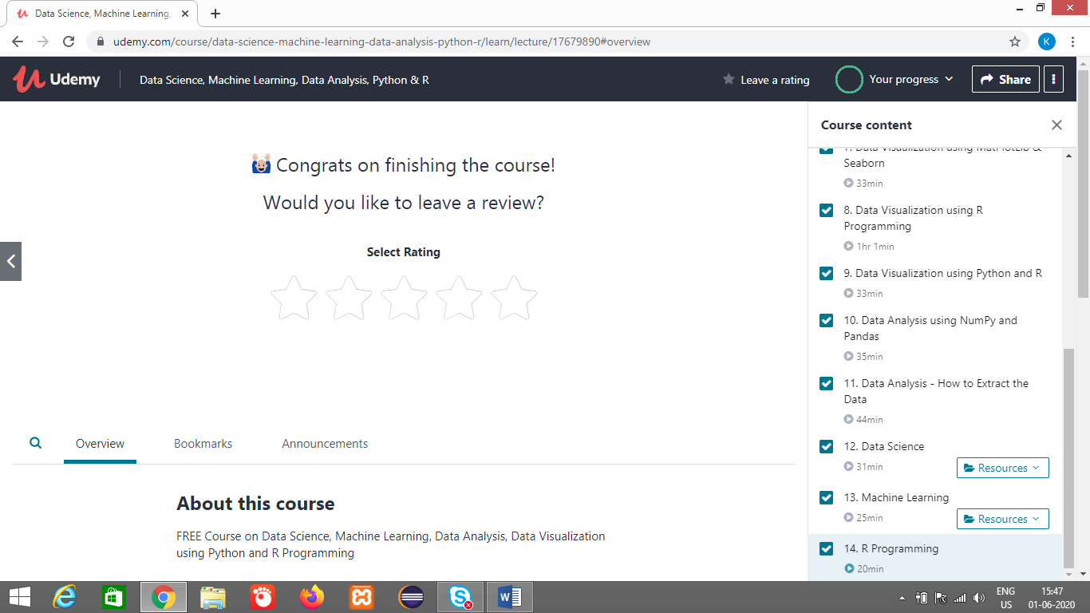

<https://github.com/alvas-education-foundation/kavya-onlinecourse>

<https://github.com/kavya-077/DAILY-STATUS>

Coding Challenges Details: (Attach the snapshot and briefly write the report for the same)

<https://github.com/kavya-077/DAILY-STATUS>

<https://github.com/alvas-education-foundation/kavya-OCA>